Lane to Byte Mapping Functional Design Specifications
UCIe 3.0 Physical Layer
Version 1

Block Owner
ENG. Karim Waseem
Authors
Mahmoud Hesham

This Page is left Blank Intentionally

Table of Contents
1 Table of Contents 1
2 Revision History 4
3 Overview 5
4 Operation and Description 5
4.1 Digital Interface 5
4.1.1 Parameters Names 5
4.1.2 Ports Names 5
4.2 Functional Description 7
4.2.1 Input Interface and Control Signals 7
4.2.2 Lane Mapping Decoder 7
4.2.3 Enable Gating Logic 7
4.2.4 Data Multiplexing and Grouping 7
4.2.5 Reordering block 8
4.2.6 Output Selection and Formatting 8
4.3 Block Diagram 9
4.4 Timing Diagram 9
4.5 Verification Requirements 10

Revision History
Version | Date | Author(s) | Revision Notes | Owner Approval

Overview
This block implements a configurable multi-lane data aggregation and packing unit.
It receives 16 parallel input lanes, each 64 bits wide, and assembles them into a single 2048-bit output word.
The block supports multiple lane mapping modes (x16, x8, x4) selected via a lane map control code. Based on the selected mode, input lanes are conditionally enabled, multiplexed, and accumulated using mode-specific shift registers. A final output multiplexer selects the correctly packed data path and drives the output interface.

Operation and Description

Digital Interface

Parameters Names
Parameter Name | Default | Description
pDATA_IN_WIDTH | 64 | Input data word width
pDATA_OUT_WIDTH | 2048 | Output data word width

Ports Names
Port Name | Port Width | Port Type | Description
i_lane_0 | pDATA_IN_WIDTH | input | Parallel input data lanes that will be packed. Each lane provides a 64-bit data word at each cycle
i_lane_1 |  | input
i_lane_2 |  | input
i_lane_3 |  | input
i_lane_4 |  | input
i_lane_5 |  | input
i_lane_6 |  | input
i_lane_7 |  | input
i_lane_8 |  | input
i_lane_9 |  | input
i_lane_10 |  | input
i_lane_11 |  | input
i_lane_12 |  | input
i_lane_13 |  | input
i_lane_14 |  | Input
i_lane_15 |  | input
i_lane_map_code [2:0] | 3 | input | Lane Map Code. Selects lane mapping configuration as listed in 4.1.3.
i_clk | 1 | input | Clock used in design
i_enable | 1 | input | Enable for lane to byte mapping block
i_reset | 1 | input | Reset for the system
i_lane_map_code | 3 | input | Control signals determine functional lanes
o_pl_valid | 1 | input | Flag to controllers that indicates data packed and valid
o_pl_data | pDATA_OUT_WIDTH | output | Output packed data

    - Standard Package Logical Lane Map
Lane Map Code | Functional Lanes | Decodings{mux_8,mux_4,x16_en,x8_en,x4_en}
000b | None (Degrade not possible) | 0 0 1 0 0
001b | Logical Lanes 0 to 7 | 0 0 0 1 0
010b | Logical Lanes 8 to 15 | 1 0 0 1 0
011b | 0 - 15 | 0 0 1 0 0
100b | Logical Lanes 0 to 3 | 0 0 0 0 1
101b | Logical Lanes 4 to 7 | 0 1 0 0 1

mux_8 : determines which lanes will be taken (0 to 7) or (8 to 15)
mux_4: determines which lanes will be taken (0 to 3) or (4 to7)
en_x16 : enable signal for x16 lanes shift registers
en_x8 : enable signal for x8 lanes shift registers
en_x4 : enable signal for x4 lanes shift registers

Functional Description

4.2.1 Input Interface and Control Signals

Sixteen parallel input data lanes (i_lane_0 to i_lane_15) provide 64-bit data words.

All inputs are sampled on the rising edge of i_clk when i_enable is asserted.

The i_reset signal clears all internal storage elements and control logic.

4.2.2 Lane Mapping Decoder

The i_lane_map_code input is decoded to generate mode-specific enable signals:

x16_en , x8_en , x4_en

mux_x4 , mux_x8

These enable signals control:

Which shift registers are active

Which multiplexers are enabled

The final output selection

Only one lane mapping mode is active at any given time.

4.2.3 Enable Gating Logic

Each mapping mode enable is logically ANDed with i_enable.

This ensures that no data is captured or shifted unless the block is explicitly enabled.

4.2.4 Data Multiplexing and Grouping

Depending on the selected mode, input lanes are grouped using multiplexers:

x16 Mode

Each input lane feeds its own 128-bit shift register.

All 16 lanes operate independently and in parallel.

x8 Mode

Input lanes are selected using 2-to-1 multiplexers.

Each pair feeds a 256-bit shift register.

Eight shift registers operate in parallel.

x4 Mode

Input lanes are selected using 2-to-1 multiplexers.

Each group feeds a 512-bit shift register.

Four such shift registers operate in parallel.

The multiplexers ensure correct lane selection and alignment for each mode.

4.2.5 Shift Register Accumulation

Shift registers accumulate incoming 64-bit data words on each clock cycle.

Data is shifted until the full register width is filled.

The number of clock cycles required to complete accumulation depends on the active lane mapping mode.

All shift registers are synchronously reset by i_reset.

4.2.5 Reordering block
- Concatenates output data from shift register in its order
- It works in 3 modes x16 , x8 and x4

4.2.6 Output Selection and Formatting

Outputs of the active shift register bank are routed to a final wide multiplexer.

The multiplexer selects the correct 2048-bit packed data based on the active lane mapping mode.

The selected data is driven on the o_data output bus.

Block Diagram
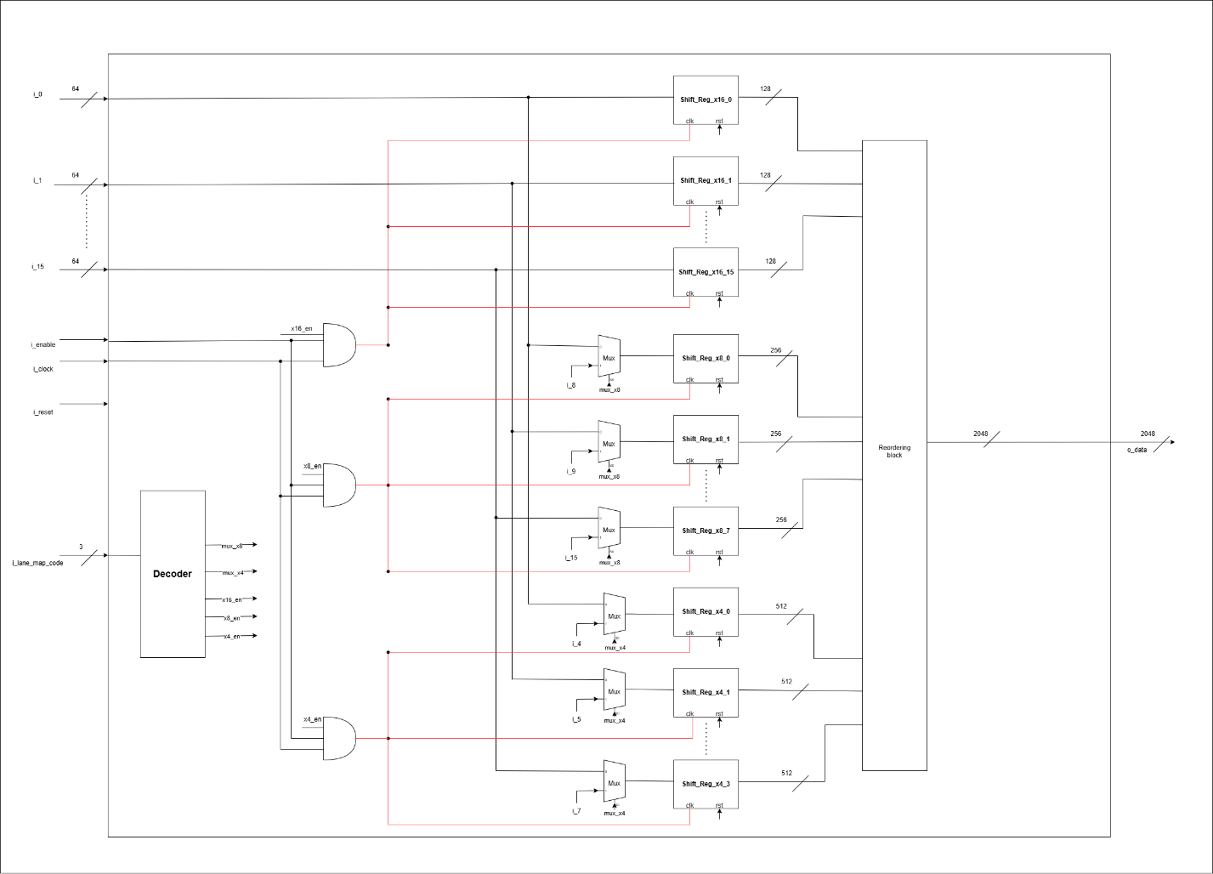

Timing Diagram
x16 lane mode:
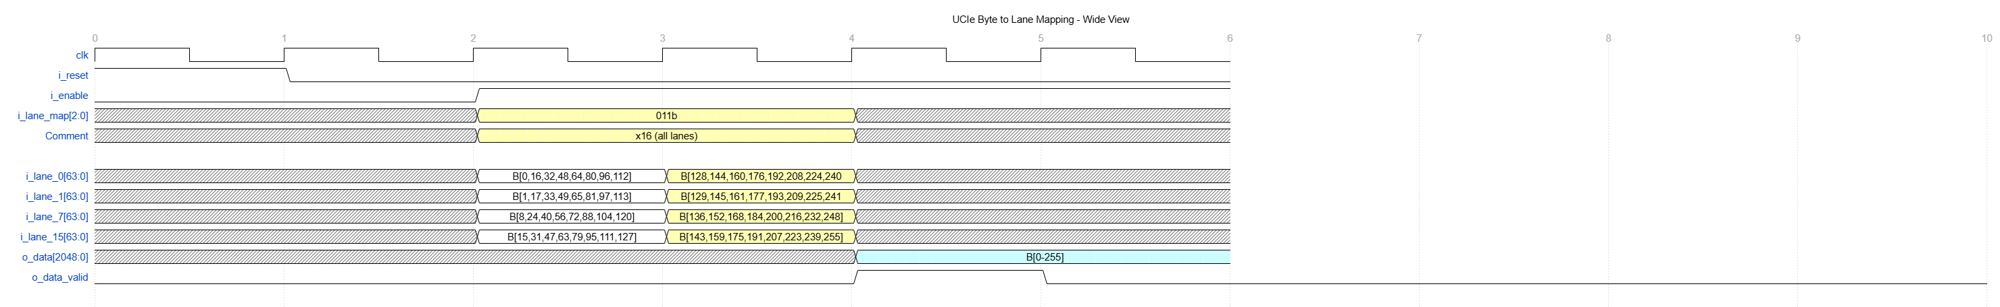
x8 Lane mode:
Lanes (0 to 7):
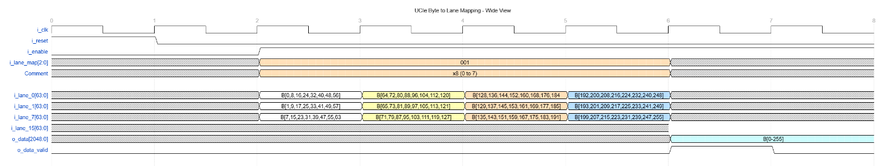
Lanes(7 to 15):
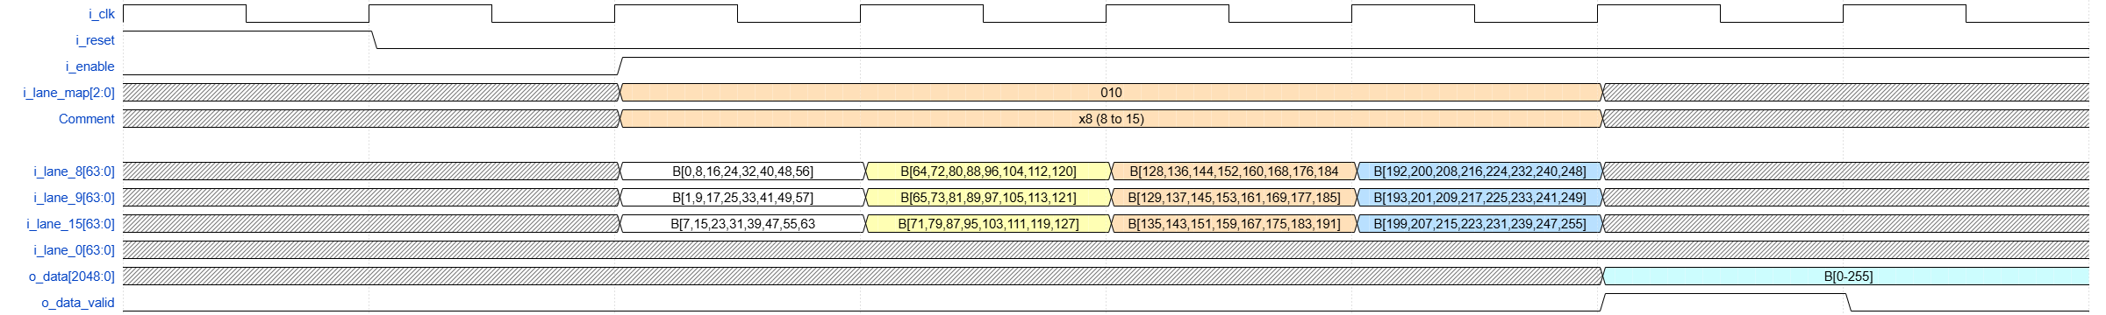
x4 Lane mode:
Lanes (0 to 3):
Lanes(4 to 7):

Verification Requirements
4.5 Verification Requirements
The following verification scenarios shall be implemented to ensure correct functionality:

4.5.1 Reset Verification
- Assert i_reset and verify that:
  - All shift registers are cleared
  - o_data is driven to zero or an invalid state
- Deassert reset and confirm normal operation resumes.

4.5.2 Enable Control Verification
- Verify that data shifting occurs only when i_enable is asserted.
- Confirm that deasserting i_enable freezes internal state.

4.5.3 Lane Mapping Mode Verification
- Independently verify each lane mapping mode:
  - x16 mode
  - x8 mode
  - x4 mode
- Confirm correct enable activation and correct mux selection per mode.

4.5.4 Data Packing and Ordering
- Apply known data patterns on input lanes.
- Verify correct lane ordering, alignment, and bit placement within o_data.
- Confirm valid data flag asserted when data is ready.

